**DESGIN A ONLINE COMPILER FOR A USER DEFINED COMPUTER LANGUAGE**

**A FINAL YEAR PROJECT REPORT**

BACHELOR OF TECHNOLOGY

In

Computer Science & Engineering

(From TECHNO INDIA UNIVERSITY , West Bengal)

**SUBMITTED BY:**

**RONIT ROY-201001001185**

**SRINATH PARAMANIK-201001001199**

**RIYAN BARUA-201001051002**

Under the Supervision of

Dr. Shaswati Roy

And

Dr. Rituparna Bhattacharya



Department of computer science & engineering

Techno India university

Kolkata -700091

*Department of Computer Science & Engineering*

*T*echno Main Salt Lake EM-4/1,

Salt Lake City, Kolkata-700091.

**Bonafide Certificate**

Certified that this synopsis for the project titled “**DESGIN A ONLINE COMPILER FOR A USER DEFINED COMPUTER LANGUAGE**

” is a part of the project work being carried out by Mr.Srinath Paramanik , Mr.Ronit Roy , Mr. Riyan Barua.

Full Signature of the Candidates (with date)

__________________ 1.

__________________ 2.

__________________ 3.

________________ (sign of mentor)

Dr. Rituparna bhattacharya(HOD, Dept of CSE)

**ACKNOWLEDGEMENT**

It gives us immense pleasure to express our deepest sense of gratitude and sincere thanks to the to the teaching fraternity of the Department of Computer Science & Engineering, for giving us this opportunity to undertake this project and also supporting us whole heartedly. We also wish to express our gratitude to the HOD and all our teachers of the Department Computer Science & Engineering for their kind hearted support, guidance and utmost endeavor to groom and develop our academic skills. At the end we would like to express our sincere thanks to all our friends and others who helped us directly or indirectly during the effort in shaping this concept till now.

Full Signature of the Candidates (with date)

1. __________________
2. __________________

3. __________________

|  |  |  |
| --- | --- | --- |
| **Chapter No.** | **Title** | **Page No.** |
| 1. | INTRODUCTION | 01 |
| 2. | ARCHITECTURE OF LANGUAGE | 03 |
| 3. | DIFFERENT MODULES OF PROJECT | 04 |
| 4. | CONTEXT FREE GRAMMAR | 05 |
| 5. | DESIGN STRATEGY   * SYMBOL TABLE CREATION * ABSTRACT SYNTAX TREE * INTERMEDIATE CODE GENERATION * CODE OPTIMIZATION * ERROR HANDLING * TARGET CODE GENERATION | 07 |
| 6. | IMPLEMENTATION DETAILS   * SYMBOL TABLE CREATION * ABSTRACT SYNTAX TREE * INTERMEDIATE CODE GENERATION * CODE OPTIMIZATION * ASSEMBLY CODE GENERATION * ERROR HANDLING * BUILD AND RUN THE PROGRAM | 09 |
| 7. | RESULTS AND SHORTCOMINGS | 14 |
| 8. | SNAPSHOTS | 15 |
| 9. | CONCLUSIONS | 23 |
| 10. | FUTURE ENHANCEMENTS | 24 |
| REFERENCES | | 25 |

|  |  |
| --- | --- |
|  |  |

# INTRODUCTION

The Mini-Compiler, contains all phases of compiler has been made for the language Python by using C language (till intermediate code optimisation phase) and we used Python language itself for target code generation as well .

The constructs that have been focused on are ‘if-else’ and ‘while’ statements. The optimizations handled for the intermediate code are ‘packing temporaries’ and ‘constant propagation’. Syntax and semantic errors have been handled and syntax error recovery has been implemented using Panic Mode Recovery in the lexer.

The screenshots of the sample input and target code output are as follows:

**Sample Input:**

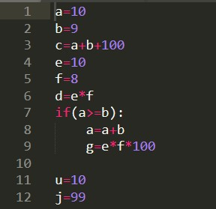

**Sample Output:**

This the target code which is generated after ICG

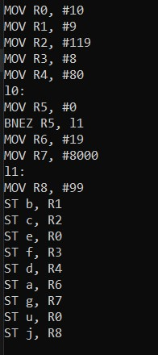

# ARCHITECTURE OF LANGUAGE

For this mini-compiler, the following aspects of the Python language syntax have been covered:

* Constructs like ‘if-else’ and ‘while’ and the required indentation for these loops.
* Nested loops
* Integer and float data types

Specific error messages are displayed based on the type of error. Syntax errors are handled using the yyerror() function, while the semantic errors are handled by making a call to a function that searches for a particular identifier in the symbol table. The line number is displayed as part of the error message.

As a part of error recovery, panic mode recovery has been implemented for the lexer. It recovers from errors in variable declaration. In case of identifiers, when the name begins with a digit, the compiler neglects the digit and considers the rest as the identifier name.

Languages used to develop this project:

* C
* YACC
* LEX
* PYTHON

# DIFFERENT MODULES OF PROJECT

•**Different Folders:** 

1. **Token_And Symbol_Table**: This folder contains the code that outputs the tokens and the symbol table.
2. **Abstract_Syntax_Tree**: This folder contains the code that displays the abstract syntax tree.
3. **Intermediate_Code_Generation**: This folder contains the code that generates the symbol table before optimisations and the intermediate code.
4. **Optimised_ICG:** This folder contains the code that generates the symbol table after optimisations, the quadruples table and the optimised intermediate code.
5. **Target_Code**: This folder contains the code that displays the assembly code/target code.

•**Different Files:** 

1. **proj.l**: It is the Lexical analyser file which defines all the terminals of the productions stated in the yacc file. It contains regular expressions.
2. **proj1.y**: Yacc file is where the productions for the conditional statements like if-else and while and expressions are mentioned. This file also contains the semantic rules defined against every production necessary. Rules for producing three address code is also present.
3. **final.py**: It is the python file which converts the ICG to target code using regex.
4. **inp.py:** The input python code which will be parsed and checked for semantic correctness by executing the lex and yacc files along with it.

# CONTEXT-FREE GRAMMAR

|  |  |
| --- | --- |
| **REGEX** |  |
| digits | -> [0-9] |
| num | -> digits+(\.digits+)?([Ee][+|-]?digits+)? |
| id | -> [a-zA-Z][a-zA-Z0-9]* |
| integer | -> [0-9]+ |
| string | -> [a-z | A-Z | 0-9 | special]* |
| special | -> [ ! " # $ % & \ ( ) * + , - . / : ; < = > ? @ [ \ \ ] ^ _ ` { | } ~ ] |

## GRAMMAR

P ->S

S ->Simple S | Compound S | epsilon

Simple ->Assignment LB | Cond LB | Print LB | break | pass | continue

Assignment -> id opassgn E1 | id opassgn cond | id listassgn Arr

| id strassgn Str

|  |  |  |
| --- | --- | --- |
|  | |  |
| E1 | | -> E1 op1 E2 | E2 |
| E2 | | -> E2 op2 E3 | E3 |
| E3 | | -> E4 op3 E3 | E4 |
| E4 | | -> num | id | (E1) |
| opassgn | | -> = | /= | *= | += | -= |
| op1 | | -> + | - |
| op2 | | -> / | * |
| op3 | | -> ** |
| LB | | -> \n |
| listassgn | | -> = |
| strassgn | | -> = | += | -= |
| Arr | | ->[list] | [list] mul | [list] add | mat |
| mat | | -> [listnum] | [liststr] |
| list | | -> listnum | liststr | Range |
| listnum | | -> num,listnum | epsilon | num |
| liststr | | -> Str,liststr | epsilon | Str |
| mul | -> * integer |
| add | -> + Arr |
| Range | -> range ( start , stop , step ) |
| start | -> integer | epsilon |
| stop | -> integer |
| step | -> integer | epsilon |
| Str | -> string | string mul | string addstr |
| addstr | -> + string |

Compound -> if_else LB | while_loop LB

if_else -> if condition : LB IND else | if condition : LB IND

| if condition : S | if condition : S else

else -> else : LB IND | else : S

while_loop -> while condition : LB IND | while condition : S

condition -> cond | (cond)

|  |  |
| --- | --- |
| cond | -> cond opor cond1 | cond1 |
| cond1 | ->cond1 opand cond2 | cond2 |
| cond2 | -> opnot cond2 | cond3 |
| cond3 | -> (cond) | relexp | bool |
| relexp | -> relexp relop E1 | E1 | id | num |
| relop | ->< | > | <= | >= | == | != | in | not in |
| bool | -> True | False |
| opor | -> || | or |
| opand | ->&& | and |
| opnot | -> not | ~ |
| IND | -> indent S dedent |
| indent | -> \t |
| dedent | -> -\t |
| Print | -> print ( toprint ) | print ( toprint,sep ) | print ( toprint,sep,end )| print ( toprint,end ) |
| toprint | -> X | X,toprint | epsilon |
| X | -> Str | Arr | id | num |
| sep | -> sep = Str |
| end | -> end = Str |

# DESIGN STRATEGY

## 1)SYMBOL TABLE CREATION

Linked list is being used to create the symbol table. The final output shows the label, value, scope, line number and type. We have created three functions to generate the symbol table. They are:

* Insert: It pushes the node onto the linked list.
* Display: It displays the symbol table.
* Search: It searches for a particular label in the linked list.

## 2)ABSTRACT SYNTAX TREE

This is being implemented using a structure that has three members which hold the data, left pointer and right pointer respectively. The functions that aid in creating and displaying this tree are:

* BuildTree: It is used to create a node of this structure and add it to the existing tree.
* printTree: This function displays the abstract syntax tree using pre-order traversal.

## 3)INTERMEDIATE CODE GENERATION

We have used the stack data structure to generate the intermediate code that uses some functions, which are called based on some conditions.

## 4)CODE OPTIMIZATION

A data structure known as quadruple is used to optimize the code. This data structure holds the details of each of the assignment, label and goto statements.

## 5)ERROR HANDLING

* Syntax Error:

If the token returned does not satisfy the grammar, then yyerror() is used to display the syntax error along with the line number.

* Semantic Error:

If there is an identifier in the RHS of an assignment statement, the symbol table is searched for that variable. If the variable does not exist in the symbol table, this is identified as a semantic error and is displayed.

* Error Recovery:

Panic Mode Recovery is used as the error recovery technique, where if the variable declaration has been done with a number at the start, it ignores the number and considers the rest as the variable name. This has been implemented using regex.

## 6)TARGET CODE GENERATION

The optimised intermediate code is read from a text file, line after line, and goes through a series of if-else loops to generate the target code. A hypothetical target machine model has been used as the target machine and the limit on the number of reusable registers has been set to 13, numbered from R0 to R12. A hypothetical machine model has been used that follows the following instruction set architecture:

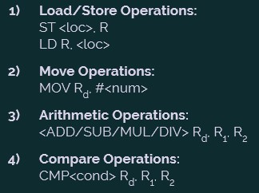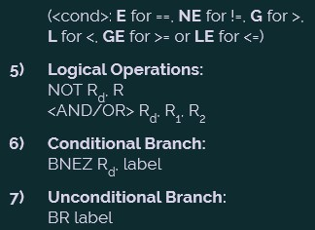

# IMPLEMENTATION DETAILS

## 1)SYMBOL TABLE CREATION

The following snapshot shows the structure declaration for symbol table:

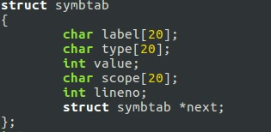

These are the functions used to generate the symbol table:



These snapshots are taken from proj1.y file in Token and Symbol table folder.

## 2)ABSTRACT SYNTAX TREE

The following data structure is used to represent the abstract syntax tree:

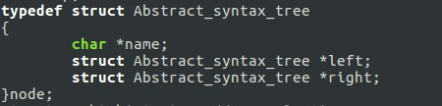

The following functions build and display the syntax tree:



These snapshots are taken from proj1.y file in Abstract syntax tree folder.

## 3) INTERMEDIATE CODE GENERATION

The following arrays act as stacks and are used for the generation of intermediate code:

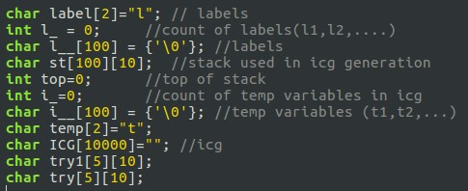

The following functions push onto the stack and generate the intermediate code, when called based on various conditions:

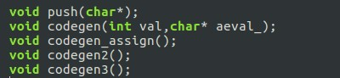

These snapshots are taken from proj1.y file in ICG folder.

## 4) CODE OPTIMISATION

The data structure quadruple declaration has been shown below:

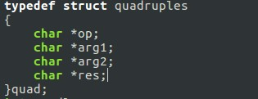

The following functions are used to add to the quadruples table and display it onto the terminal:



These snapshots are taken from proj1.y file in Optimised_ICG folder.

## 5)TARGET CODE GENERATION

A global dictionary holds the mapping between each constant/identifier and the corresponding register that holds that constant/identifier. There also is a global list that holds the identifiers that need to be stored towards the end of the program.

There are two functions which are used for register allocation. The

‘getreg()’ function gets the next free/unallocated register and uses the

‘fifo()’ function in cases when all the registers are used up. The ‘fifo()’ function uses the ‘First In First Out’ method to free a register and return it to the ‘getreg()’ function. These functions are as follows:

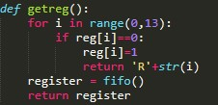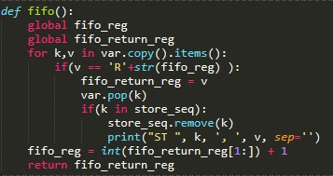

These snapshots are taken from final.py file in Target_Code folder.

10

## 6)ERROR HANDLING

* The following snapshot shows the error handling function for syntaxerrors: 

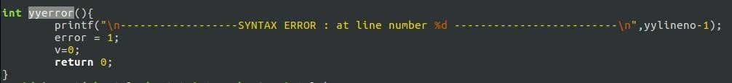

* The following snapshot shows semantic error handling functionality: 

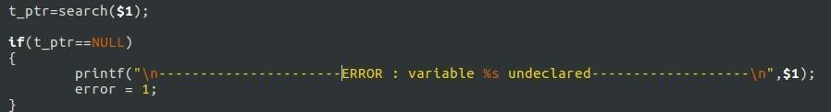

These above snapshots are taken from proj1.y file in Symbol table folder.

* The regex for panic mode recovery implemented in the lexer is as follows: 



The above snapshots are taken from proj.l file in Symbol table folder.

**BUILD AND RUN THE PROGRAM:**

The following screenshot displays what commands need to be executed to build and run the program:

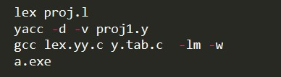

The above commands need to be executed on the terminal which is inside the project folder that contains the code for the compiler.

# RESULTS AND SHORTCOMINGS

The mini-compiler built in this project works perfectly for the ‘if-else’ and ‘while’ constructs of Python language. Our compiler can be executed in different phases by building and running the code separated in the various folders. The final code displays the output of all the phases on the terminal, one after the other.

First, the tokens are displayed, followed by a ‘PARSE SUCCESSFUL’ message. Then abstract syntax tree is printed. Next, the symbol table along with the intermediate code is printed without optimisation. Finally, the symbol table and the intermediate code after optimisation is displayed after the quadruples table. The final output is the target code, written in the instruction set architecture followed by the hypothetical machine model introduced in this project. This is for inputs with no errors. But in case of erroneous inputs, the token generation is stopped on error encounter and the corresponding error message is displayed.

This mini-compiler has the following shortcomings:

* User defined functions are not handled.
* Importing libraries and calling library functions is not taken care of.
* Datatypes other than integer and float, example strings, lists, tuples, dictionaries, etc have not been considered.
* Constructs other than ‘while’ and ‘if-else’ have not been added in the compiler program.

**SNAPSHOTS**

**TEST CASE 1 (Correct input):**

**Input:**



**Tokens and Symbol Table:**

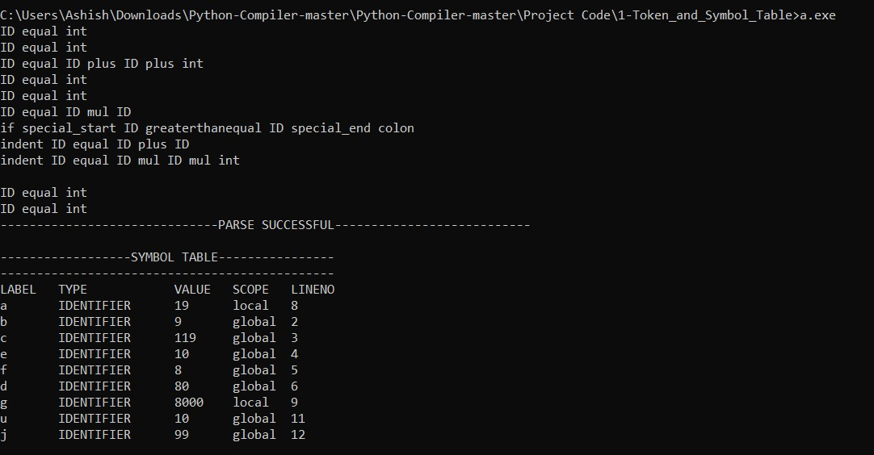

**Abstract Syntax Tree:**

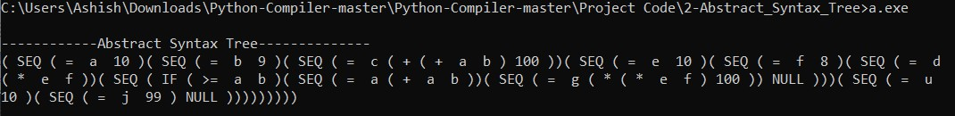

**Symbol Table and Unoptimized Intermediate Code:**

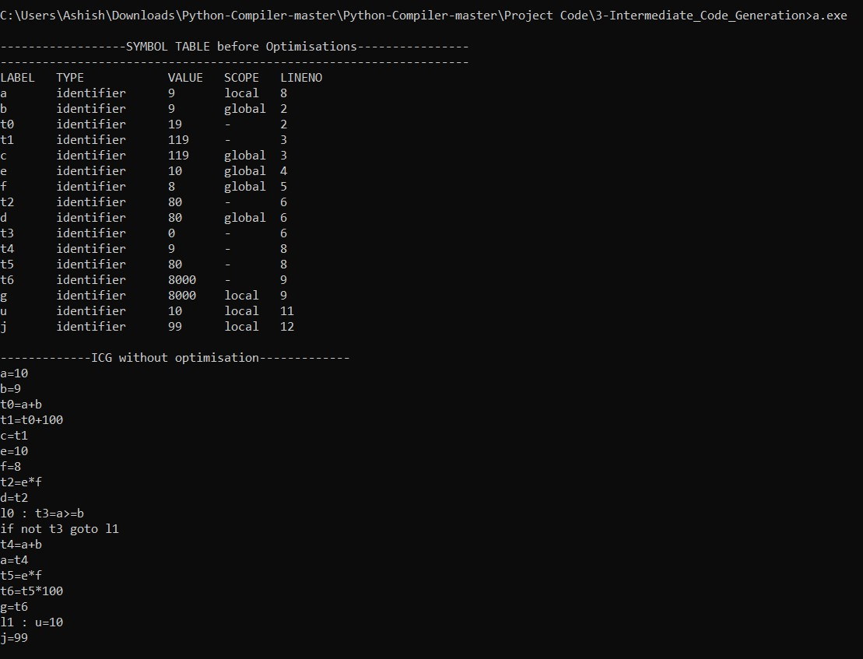

**Symbol Table, Quadruples Table and Optimised Intermediate Code:**

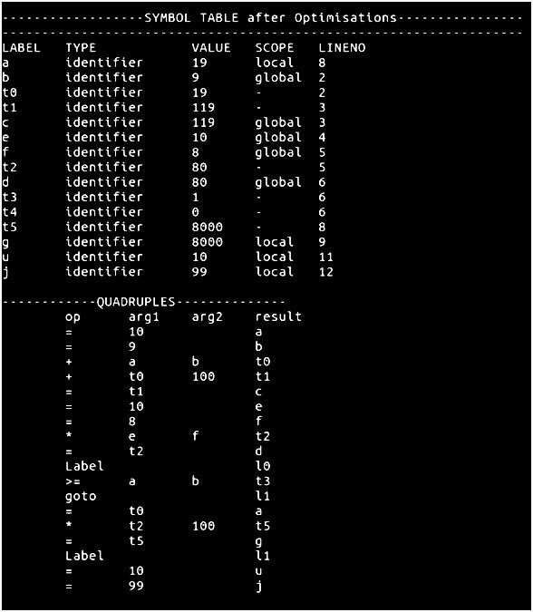

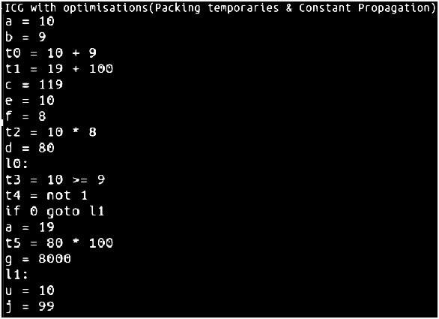

**Target Code:**



**TEST CASE 2 (Syntax Error):**

**Input:**

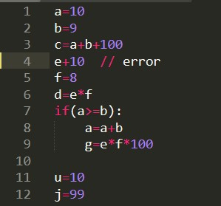

**Output:**

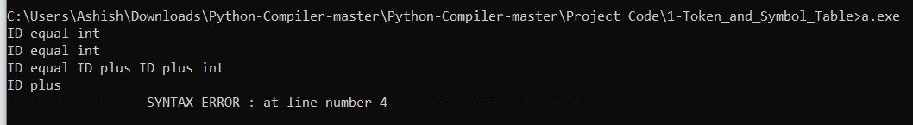

**TEST CASE 3 (Semantic Error):**

**Input:**

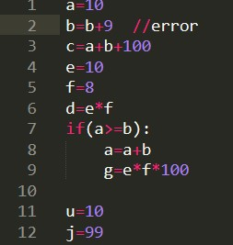

**Output:**



**TEST CASE 4 (Error Recovery):**

**Input:**



**Output:**

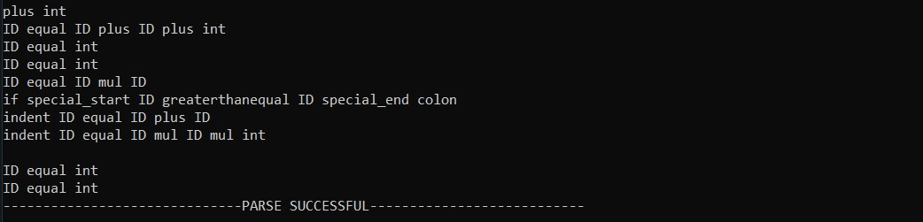

# CONCLUSIONS

•Making a full complete compiler is a very difficult task and it takes lots of time to make it. So, we have successfully made a mini compiler which performs following operations:

1. This is a mini-compiler for python using lex and yacc files which takes in a python program and according to the context free grammar written, the program is validated.
2. Regular Expressions are written to generate the tokens.
3. Symbol table is created to store the information about the identifiers.
4. Abstract syntax tree is generated and displayed according to the pre-order tree traversal.
5. Intermediate code is generated, and the data structure used for optimisation is Quadruples. The optimisation techniques used are constant propagation and packing temporaries.
6. The optimised intermediate code is then converted to the Target code using a hypothetical machine model.
7. Error handling and recovery implemented take care of erroneous inputs.

# FUTURE ENHANCEMENTS

This mini-compiler can be enhanced to a complete compiler for the Python language by making a few improvements. User defined functions can be handled and the functionality of importing libraries and calling library functions can be taken care of. Datatypes other than integer, example strings, lists, tuples, dictionaries, etc can be included and constructs other than ‘while’ and ‘if-else’, like ‘for’ can be added in the compiler program. The output can be made to look more enhanced and beautiful. The overall efficiency and speed of the program can be improved by using some other data structures, functions or approaches.

# REFERENCES

1. **Lex and Yacc**

<http://cse.iitkgp.ac.in/~bivasm/notes/LexAndYaccTutorial.pdf>

1. **Introduction about Flex and Bison**<http://dinosaur.compilertools.net/>
2. **Full Grammar Specification**

<https://docs.python.org/3/reference/grammar.html>

1. **Introduction to Yacc**

<https://www.inf.unibz.it/~artale/Compiler/intro-yacc.pdf>

1. **Intermediate Code Generation**

<https://2k8618.blogspot.com/2011/06/intermediate-code-generator-for.html?m=0>

1. **Target Code Generation**

<https://web.cs.ucdavis.edu/~pandey/Teaching/ECS142/Lects/final.codegen.pdf>

<https://www.javatpoint.com/code-generation>

1. **A Code Generator to translate Three-Address intermediate code to**

**MIPS assembly code**<https://www2.cs.arizona.edu/~debray/Teaching/CSc453/DOCS/3addr2spim.pdf>